
REGIONAL CONFERENCE
Saturday 20th June 2026
Portsmouth Grammar School
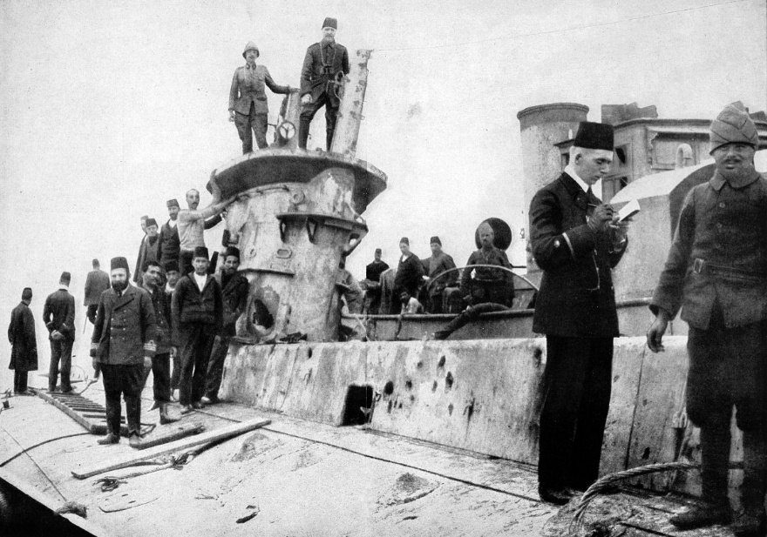
High Street, Portsmouth, Hampshire, PO1 2LN

The Gallipoli Association 6th Regional Conference this year will be held in Portsmouth.
A famous alumnus of the school was Lt Norman Holbrook VC, who commanded the submarine B11 at Gallipoli. This is a great opportunity to network with fellow members and other attendees. Cost for the day will be £35 and this includes tea/coffee and a buffet lunch. Registration will be from 9.30am and the day is planned to finish at 4.00pm. There is ample free parking at the school for the day.

The talks will be a mix of keynote and breakout mini-talks that will include:

- Malcolm Bryne Avery OBE - ‘A New Breed of Warrior - Submarines in the Dardanelles’
- Sophie Haworth - ‘Gallipoli’
- Roger Cooper-Simpson - “Bound for Somewhere” - The Journal of Lieutenant Thomas Cooper-
- Simpson MC RE, 1/2nd West Lancashire Field Company, Royal Engineers’
- Brian Cleary - ‘Lily Doughty-Wylie - How two medals revealed an incredible story’
- Stephen Chambers - ‘Valour, Bravery and Torpedoes - For Services in Picket Boats’
- Hester Huttenbach - ‘A Father’s Story: Colonel Norman Hugh Huttenbach DSO, OBE, MC’
- Guy Lewin-Smith - ‘My Grandfather’s Compass - With the 5th Suffolks at Suvla Bay’

We are planning a visit to the Gosport Submarine or Portsmouth Historic Dockyard museums at your own expense, on the Sunday morning. Price for a group ticket is £27 per person for the day. An individual ticket valid for one year is £46. This would mean an overnight stay in one of Portsmouth’s many hotels. Both Portsmouth and Southsea and Portsmouth Harbour Railway Stations are approximately a 15- minute walk to the school. Portsmouth Harbour Station is a 3 minute walk from the dockyard.
Tickets will not be sent but you will receive an email confirmation

It is preferable to pay in the first instance by BACS to the Gallipoli Association.
Please email: events@gallipoli-association.org for the bank details.
Or by PayPal@gallipoli-association.org
or by Cheque made payable to Gallipoli Association.
Please send to: events@gallipoli-association.org
Or Post to: Hester Huttenbach, 24 Norcutt Road, Twickenham, Middlesex, TW2 6SR
_________________________________________________________________________________________

I would like to reserve _______________ place(s) for the Regional Conference @ £35 per head.
Please state if you have any dietary requirements.
Please state method of payment BACS £_________ PAYPAL £__________ Cheque £________________

NAME ____________________________________________________________________________________

GUEST NAME (if Relevant) ___________________________________________________________________

Tel No: ____________________________________________________________________________________

Email: _____________________________________________________________________________________

Would you be interested in one of the additional visits to the museums? YES / NO ________

