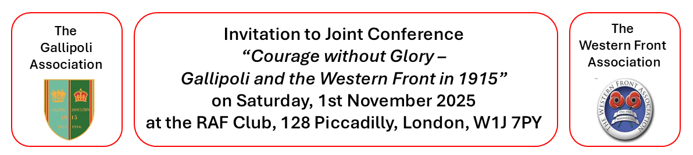Confirmed speakers below. We reserve the right to amend if circumstances require.

**Sir Hew Strachan:**

*“The strategic consequences of the Gallipoli campaign”*

**Clive Harris and Michael Keegan:**

“*From the Dardanelles to the Dover Patrol, Roger Keyes at Gallipoli and on the Western Front.”*

**Dr.** **Andrea McKenzie:**

*“Canadian Nurses: from Lemnos to the Western Front“*

**Dr. Adam Prime:**

*“The Indian Army experience in 1915 on Gallipoli and the Western Front.”*

**Professor Gary Sheffield:**

*“ Gallipoli, the Western Front, and the development of modern warfare”*

**Registration will be from 9.15am in the Foyer. The Conference will run from 10.00 - 17.00.**

**Following the joint conference, there will be a three course Gala dinner at the RAF Club at 19.00 at a cost of £65 per head excluding wine and drinks. There will be a cash bar from 17.30. These two events are open to Non-Members and their Guests.**

Please pay in the first instance by BACS made payable to the Gallipoli Association bank account at: National Westminster Bank: Sort Code 60 - 07 - 02 Account number: 03725421

Or via: [PayPal@gallipoli-association.org](mailto:PayPal@gallipoli-association.org)

Or: By cheque made payable to the Gallipoli Association

Please email your form to [events@gallipoli-association.org](mailto:events@gallipoli-association.org)

Or: Post to Hester Huttenbach, 24 Norcutt Road, Twickenham, Middlesex, TW2 6SR

_______________________________________________________________________________________

**I would like to reserve _________ place (s) for the GA/WFA Conference @ £60 per head. Please state if you require a vegetarian lunch option.**

**I would like to reserve ______ place (s) for the GA/WFA Conference and dinner at £125 per head**

**Please state if you require vegetarian dinner option.**

**Please tick method of payment: BACS £ ________PAYPAL £ ________ CHEQUE £ __________**

**NAME _________________________________________________________________________________**

**GUEST NAME (If relevant) ______________________________________________________________**

**EMAIL ________________________________________________________________________________**

**TEL NO : ______________________________________________________________________________**

**Please tick whether you heard from the GA ___________ ? WFA _____________ ?**